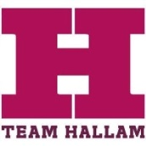
Sponsor Venue Information
What is the nature of your business?

What is your venue capacity?
How do you manage your capacity?
Do you have a smoking area?
Do you use security and if so are they internal or do you use a security company?
Are your premises Sheffield Best Bar None accreditated?
Are you a member of Sheffield license watch?
How do you deal with drunkenness on your premises?
Do you have an entry / door policy?
How do you deal with disorder
Do you have a drugs policy?
Do you serve glass on your premises?
Can you describe your fire detection/warning system for your premises?
What drinks promotions do you run on Wednesday evenings?
How do you deal with public nuisance and noise breakout?
Do you operate a student’s only policy on Wednesday nights?
Name of Bar/venue
Name of Club

Please return to the Team Hallam Sports Club Manager

